- Greenhouse Sale 2017
Sale starts: April 6th
Hours: Monday, Wednesday & Friday: 8:00am-4:00pm
Tuesday & Thursday: 8:00am-5:30pm
The greenhouse will be closed all day April 14th , 17th, 20th , 21st and May 12th . We will be closed the evenings of April 26th and May 3rd.

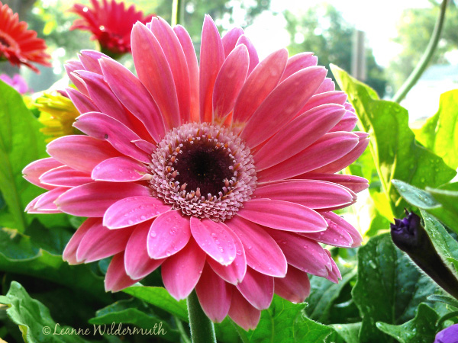

$11.00 Foliage Hanging Baskets
  - Spider Plants
  - Purple Heart Wandering Jew
  - Wandering Jew
  - Bolivian Jew
  - Swedish Ivy

$13.00 Flowering Hanging Baskets
  - Wave Petunia
  - Ivy Geranium
  - Fuchsia
- Bacopa
- Dragon Wing Begonia
- Double Impatiens
- New Guinea Impatiens
- Coleus

$1.50 Pepper 6 packs

Extra
- Mixed baskets ($15-$30)
- Basil ($1.00)

$ 1.75 6 Packs
  - Ageratum
  - Wax Begonia
  - Coleus
  - Impatiens
  - Marigolds
  - Petunia
  - Salvia
  - Portulaca (Rose Moss)
  - Snapdragon
  - Dusty Miller

$ 2.50 4 in. Pot
  - Dracaena Spike
  - Sweet potato vine
  - Vinca vine
  - Helichrysum
  - Ornamental Peppers
  - Gerbera Daisies

$ 4.00 6 in. Pot
  - Persian Shield
  - Osteospermum
  - Regal Geranium

$1.50 Tomato 6 packs
Please contact Katie Robnett
at kmilhollin@nc.k12.mo.us or 386-2661 for additional times or questions

The greenhouse is located behind NCHS
- Cherry
- Beefsteak
- Roma
- Big Boy
- Marglobe
- Early Girl
- Lemon Boy
- Better Boy

