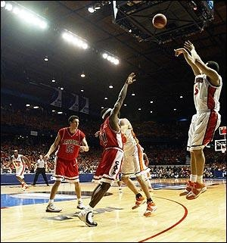
THUNDERBIRD BASKETBALL CAMP
“Add a 2”
When: June 1st – 4th
5-6th grade 5:30-7:00 pm
7-8th grade 7:00-8:30 pm

Who: Any 5th-8th grade boys basketball player who wants to improve!

Where: North Callaway High School

Why: To improve your skills as a basketball player. We will work on every aspect of the game of basketball. We want to help make you the best player we can.

Cost: $30 – includes a t-shirt

Basketball is a skill sport. There are many things that go into making a good player. Our goal is to develop all of those skills to make you the best possible player we can. We will have shooting contests and a camper of the day and week prizes to give out!
- Coach Thomas

Detach the bottom and return to Coach Thomas or your building secretary by May 22.

Name: ___________________________________Grade:(as of fall 2015): ________

Shirt size: ________

EMERGENCY CONTACT INFORMATION:

NAME:________________________________RELATIONSHIP:_________________

NUMBER: ___________________________________

North Callaway R-1School District and Coaches will not be held responsible for injuries or accidents. Please sign and date below.

Parent Signature: _______________________________ Date: _____________
www.thunderbirdproud.com

